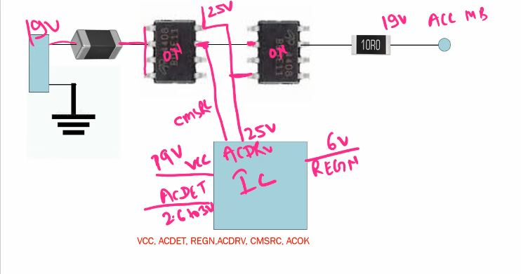
Types – N chanel, P Channel, Diode
- VCC 19V
- ACDET ~2.4-3.0V (as per voltage devider) or as a enable
- REGN 6V (ic start internal work ok)
- ACDRV (to switch on mosfet)
- CMSRC – mosfet on feedback
- AC OK `3.3 volt pull ke through – sio feedback( send msg to sio ki power aa rha hai)- ACDET is must
How to Find VIN Section in Schematics
ACP, ACN – Current measurement of CLR
Regn
VCC/DCIN – IC Power Supply
ACIN, ACOK – Output Pins (3.3 volt pull-through)
(Send msg to SIO that adapter supply CLR par pahuch gya hai(adapter or battery supply is stable)
ACDET – 2.6-3.0V Valid adapter insert hai ya nhi…
Note: ACDET nhi hoga to ACOK release nhi hoga, ACOK ka apna volt LH nhi hota hai, Pull ke through hota hai..
ACDRV – mosfet ko on krne keliye.
CMSRC – dono se source se connected, mosfet switch on feedback
REGN ~6V -VCC/ACDET valid hai to, (IC internally ok hai to)
SRP, SRN – CLR for battery current measurement ke liye.
NOTE- P Channel Concept
P-Channel MOSFET me ACDRV nhi hota hai kyu ke 25 not required
P-Channel MOSFET me CMSRC nhi hota hai
P channel low voltage = ON
Note: DC Jack voltage CLR Voltage ke equal hona chahiye…

G=S OFF
Random
Open Drain
Close Drain

ACOK – High Active 3.3V
ACOK# - low Active 0v

